
Development Request
Aria Systems
Custom Report Form

New Form Template Description

Form Template

Template Header
Product: | Aria 2.7.
Module: | Inventory Control
Customer name: | Low Profile
Report Name: | Ahead & Behind Report
Form Name: | Ahead & Behind Report
Installed Modules: | 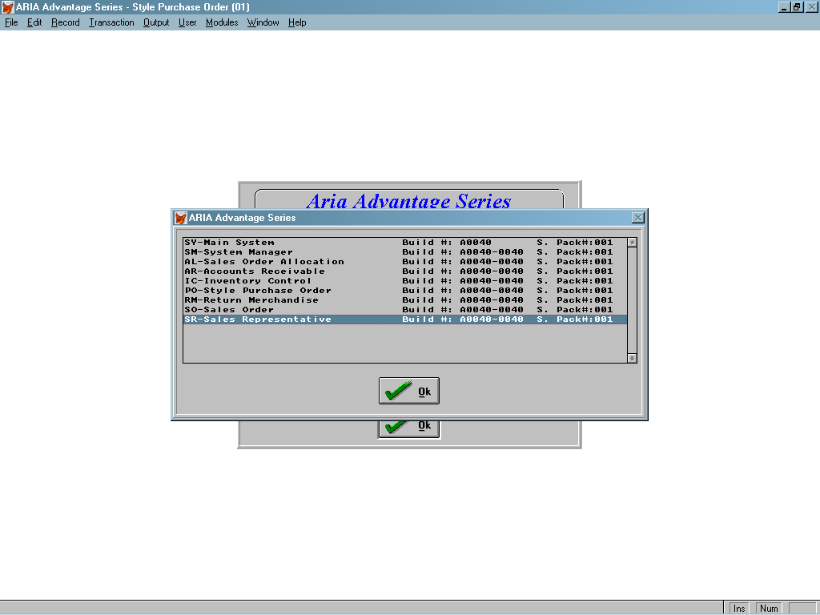
Parameters setting: | Multi-currency = Y  Multi-warehouse = Y  Style Costing method = Average  Extended sizes = Y  Style structure = 12 – 3 – 3

System Setting Report:
This is a Graphics report that will be to Microsoft Excel format
Please note that the layout of the XL sheet is how the report must look after it has been Exported.
See Grid Critera

Form Layout
See Ahead behind layout 15-12-03.xls

1 | Print | Ahead & Behind Report
2 | Print Dept | Print from Selection Grid  Print the Cdiscrep f the Department
2A | Season | Print From Critera Grid  Please print the Cdiscrep of the season
3 | Print Date | Print From and too Date selected from grid please print the date DD/MM/YYY
4 | Print style | Print from Style.dbf . Cstymajor
5 | Print Description | Print from Style Desc
6 | Print Colour | Print from Style char 14,15,16 then from Codes . Cdiscrep  Please print the Color code and the descripption
7 | Print Total Contract | This is a total ordered for each style and colour from the ordline file Totbook - cancelled  If the style / Color has more than 1 line then add them together, the orderes must be the same season
8 | Print Selling Price | Print the selling price from Style.priceA
9 | Print Actual This Week | Po receipts for the week entered in the criteria grid for style / color
9A | Print Plan this week | Just print the Heading this field will be editited once exported to XL
10 | Print Actual To Date | All Po recipts for the style and colour
10A | Print Plan to Date | Just print the Heading this field will be editited once exported to XL
10B | Print + / - | Just print the Heading this field will be editited once exported to XL
11 | Available Stock | This is the stock figure – Allocated figure
12 | Print Call off This Week | This is all style color invoiced an allocated in week the criteria grid is set to
13 | Call off to Date | This is all style color invoiced and allocated to date
14 | Stock Value at CP | This is the figure in 11 * Ave_cost from style

14A | Stock Value at SP | This is the figure in 11 * Style Price A
15 | Call off Value | Total Invoiced value + Allocated To give a total figure
16A | Print Subtotal
17 |  | Print total of Style for 7
18 |  | Print the total for 9
19 |  | Print the total 10
20 |  | Print the total 11
21 |  | Print the total 12
22 |  | Print the total 13
23 |  | Print the total 14
24 |  | Print the total 15

Grid Critera

- Department Select Cpurcode these are attached to the styles
- Season from codes
- Date From and to
- Export to Excel Yes / No Default yes if no print graphics report as landscape
- Style

Questions from Ashraf and replies from Nick:
Questions:
Hi Nick,
Please confirm the following points:
1- Dept. = Purchase group
2- Date from --> Date to must be one week. In other words the user will enter "date from" then the program will add 7 days to get the "date to"
3- The style will have more than one color and the subtotal will be for each style.

Answers:
Hi,

1- This is correct
2- Correct
3- Correct

